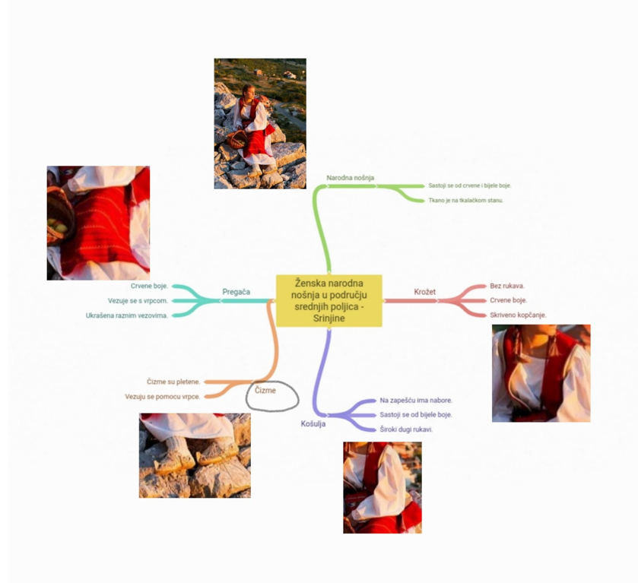
Učenica Marija Čudina 2g

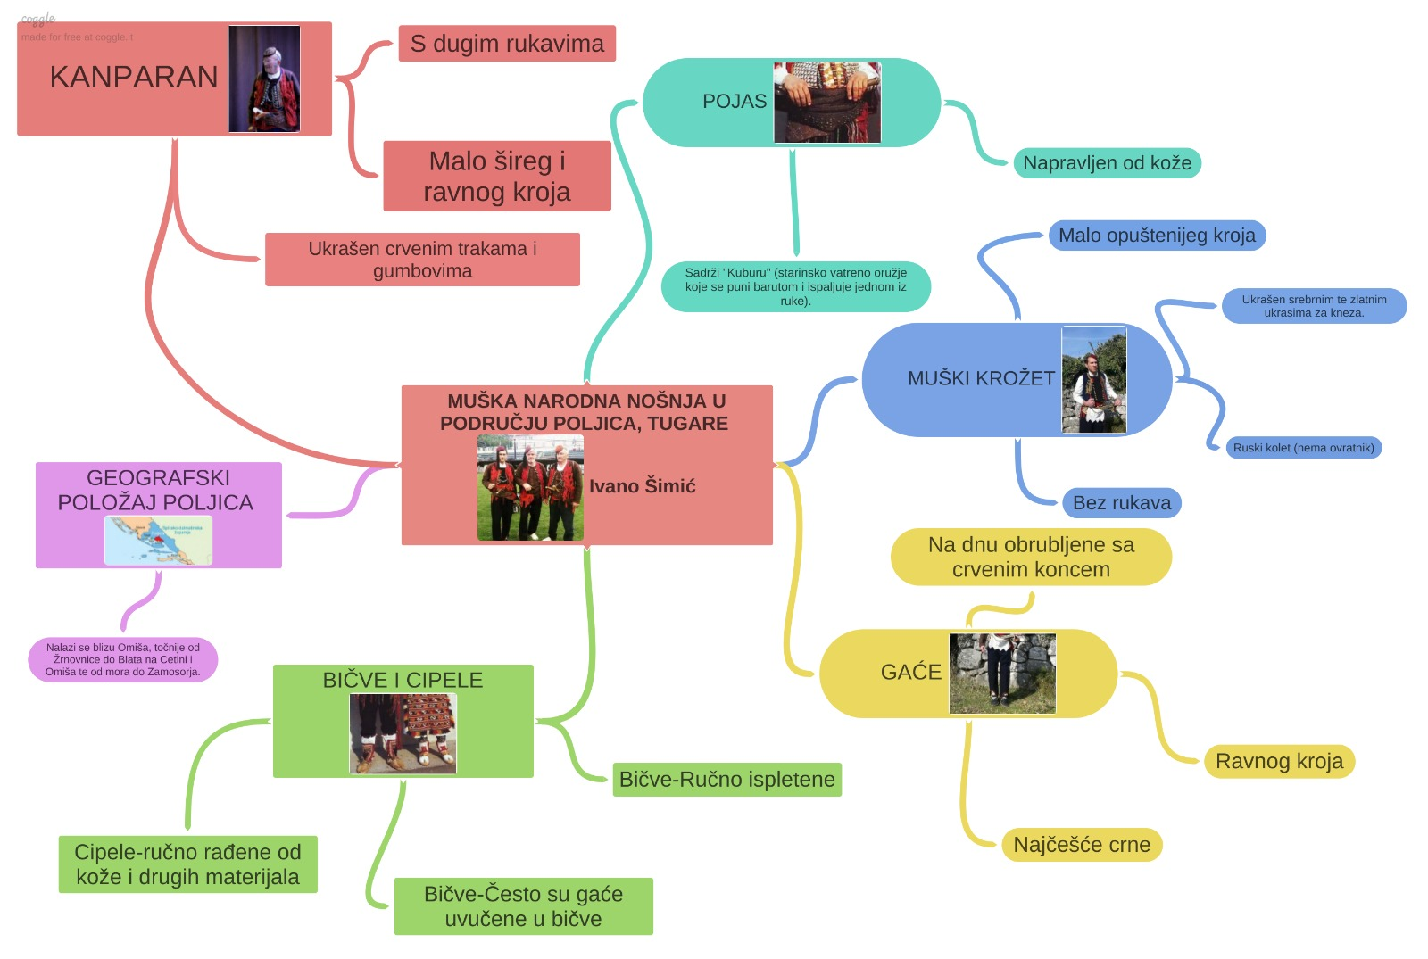
Učenik Ivano Šimić 3f

https://coggle.it/diagram/YaUFpnR39SiqbmD3/t/mu%C5%A1ka-narodna-no%C5%A1nja-u-podru%C4%8Dju-poljica-dide-ivano-%C5%A1imi%C4%87/4b63a5870a8ce5baea689116084c830f19361888ca4dbd22ba270af39966e9cb

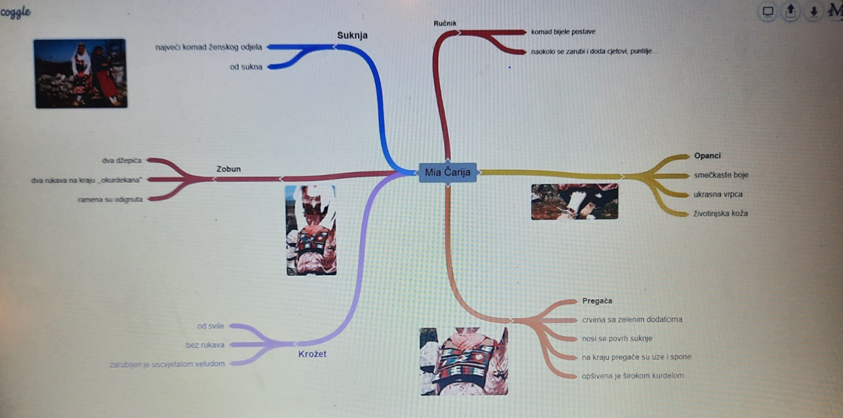
Učenica Mia Čarija 1 f
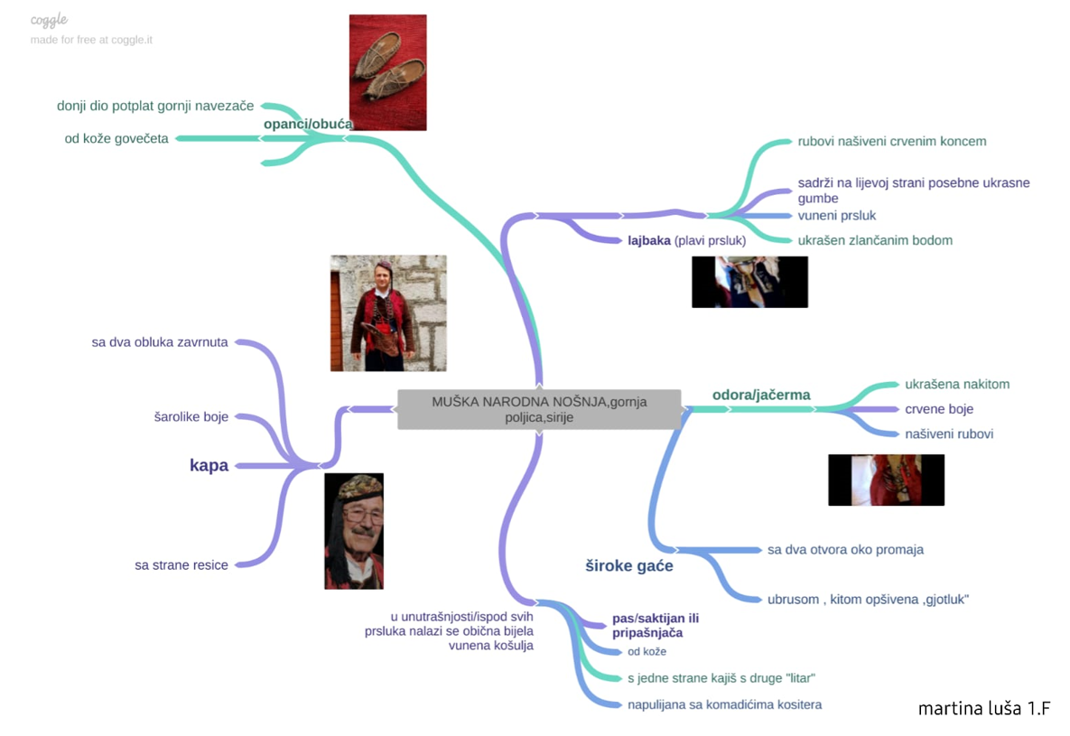
Učenica Martina Luša 1.f

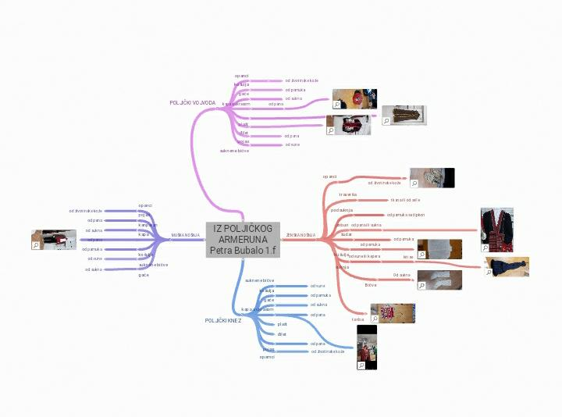
Učenica Petra Bubalo 1 f

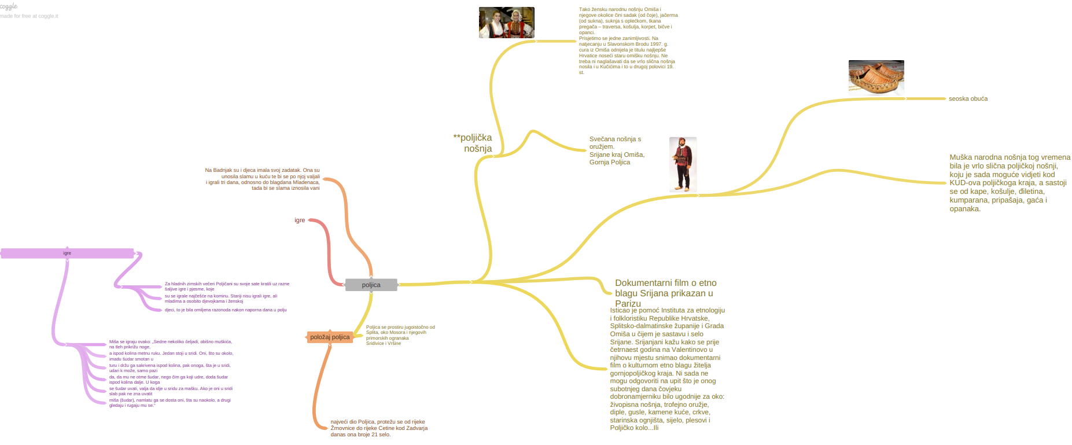

https://coggle.it/diagram/YaZiy5sSzph_CXna/t/poljica
Učenik Denis Budiša 3g

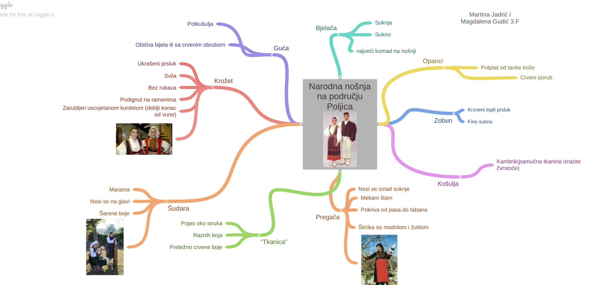

https://coggle.it/diagram/YaOxZWaAVYFmRi_z/t/narodna-no%C5%A1nja-na-podru%C4%8Dju-poljica-image-resized/aee1643d182eb32a0a0ec41ce0f00e461279eea3c98f6a97694c7439956c858d

Učenice Martina Jadrić i Magdalena Gudić 3f

https://coggle.it/diagram/YaZfyDOIUjYzm3T8/t/no%C5%A1nja-polji%C4%8Dkog-kneza/f981c4c83336a9992823ff175de213d95ea9cb93418bd2854e33710a94ff7d18
Učenica Antea Šaškor Ulenica 2f

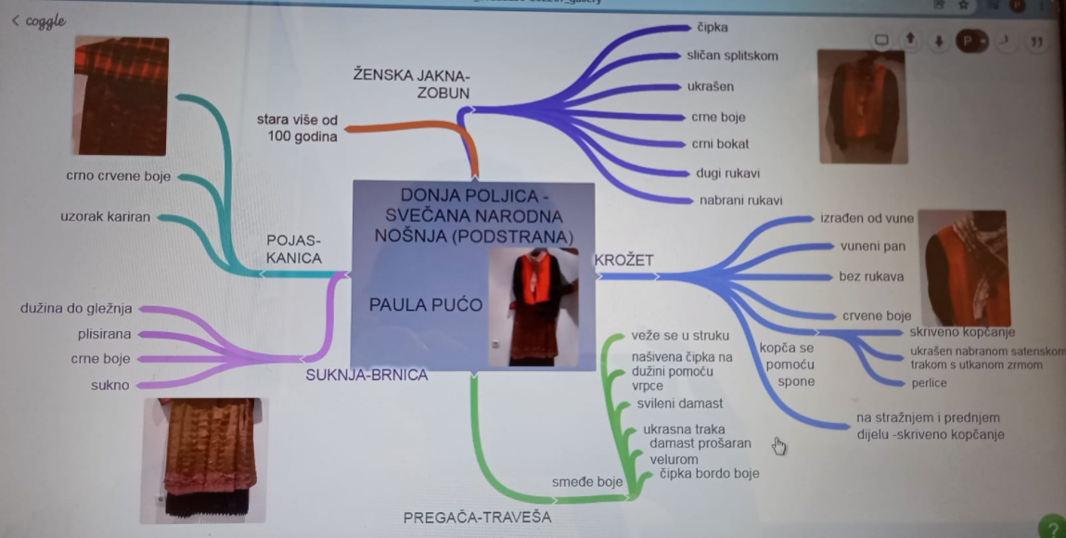

https://coggle.it/diagram/YaZ8WJsSzoPTF7un/t/donja-poljica-sve%C4%8Dana-screenshot_20211130-202207_gallery
Učenica Paula Pućo 2f

