1st PHOTOGRAPHIC PROjECT
Lord of the Flies
Our 16 year students worked on a photographic project based on the book Lord of the Flies by William Golding which demonstrates mankind's frustration with the manifestation of evil as a consequence of his own course of action as well as his inability to defeat evil. Our photographers expressed their experience of the novel through a short but significant video presentation. They converted digital color images into black and white ones. Keynote was used as a presentation software. Watch our video presentation here https://youtu.be/wJtWwtS_2LU

2nd PHOTOGRAPHIC PROJECT
Photograms and chemigrams
Photograms made by our photography students.
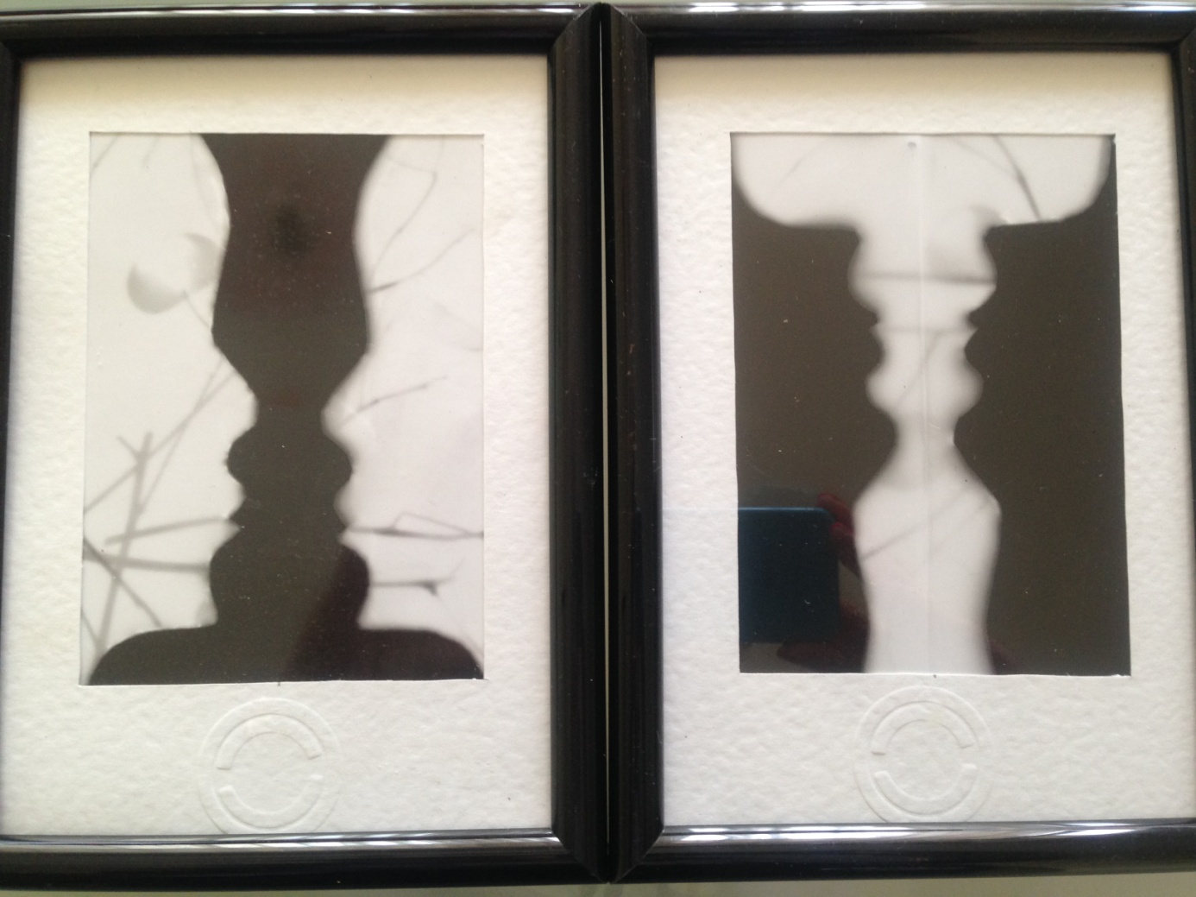

A photogram is a photographic image made without a camera by placing objects directly onto the surface of a light-sensitive material such as photographic paper and then exposing it to light. The usual result is a negative shadow image that shows variations in tone that depends upon the transparency of the objects used. Areas of the paper that have received no light appear white; those exposed through transparent or semi-transparent objects appear grey.
The technique is sometimes called cameraless photography. It was used by Man Ray in his exploration of rayographs. Variations of the technique have also been used for scientific purposes.
A solarised photogram made by our photography students.
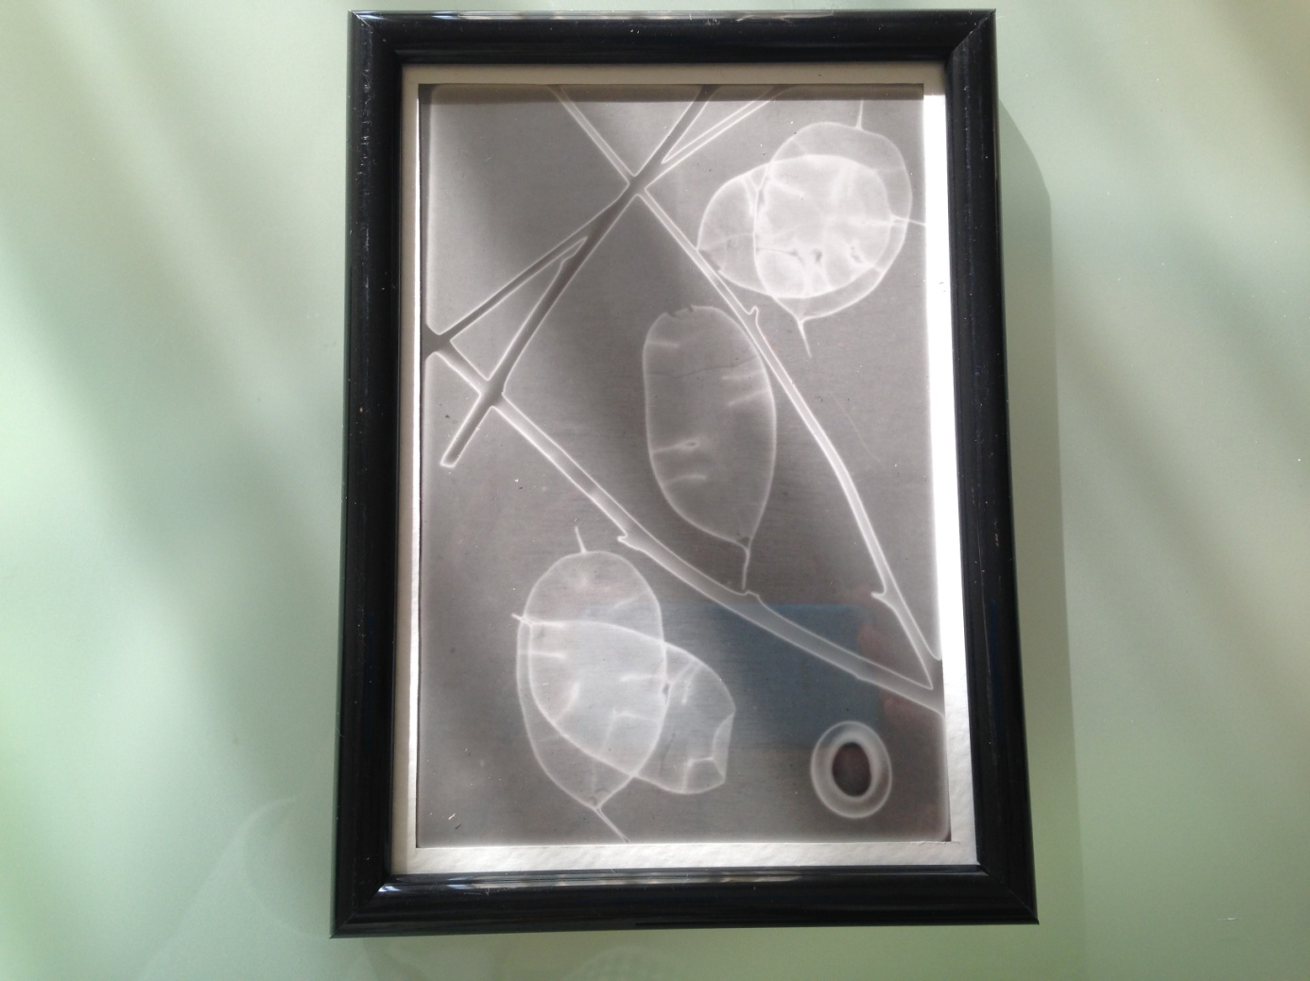
Solarisation (or solarization) is a phenomenon in photography in which the image recorded on a negative or on a photographic print is wholly or partially reversed in tone. Dark areas appear light or light areas appear dark.
Chemigrams made by our photography students. 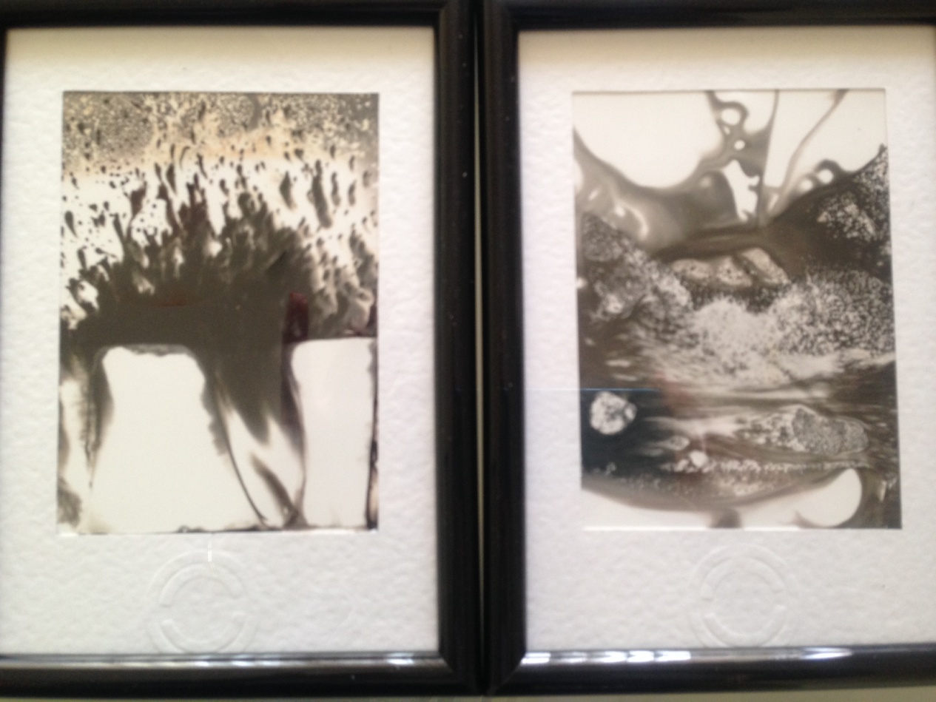
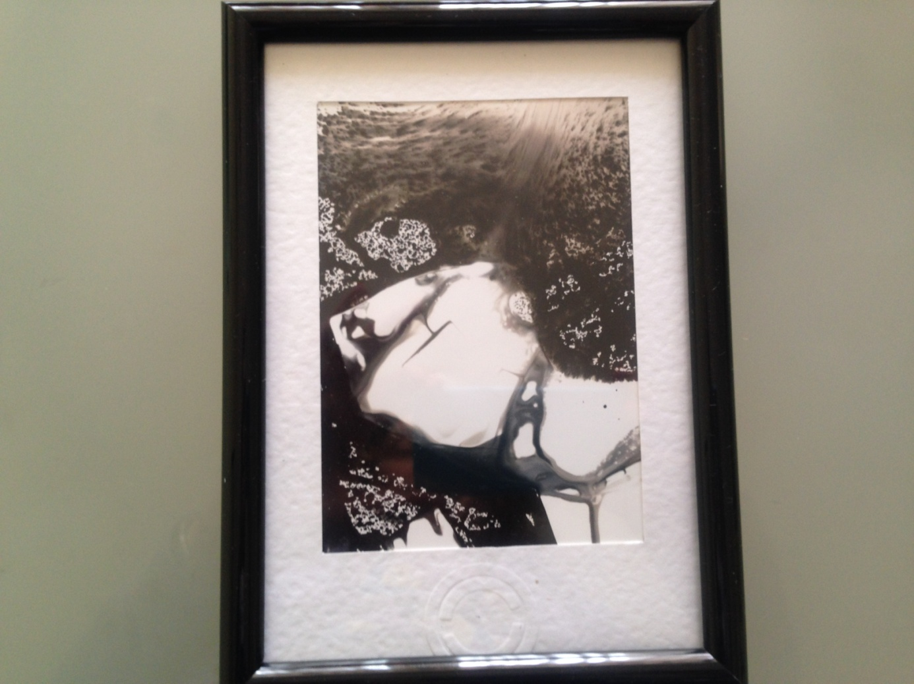
A chemigram (from "chemistry" and gramma, Greek for "things written") is an experimental art where a photographic image made by painting on a light-sensitive paper (such as photographic paper). The result resembles a watercolor painting.The chemigram is a combination of both painting and photography, and lies within the general domain of experimentation in the visual arts. It requires the use of materials from silver halide-based photography (light-sensitive paper,developer, and fixer), but it is not a photograph. Like the photogram, the chemigram is made without a camera, yet it is created in full light instead of in the darkness of the darkroom. For this reason it is not "light that writes" (photo graphein in the Greek) but rather "chemistry that writes".Chemigrams can be made solely with photo paper, developer, and fixer, with results that will somewhat resemble watercolor.
Projects were made by photography students mentored by their teacher of photography Vjeročka Milišić.

